Gas Detection
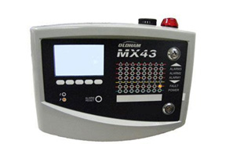

Fixed Controllers- MX 43 SIL-1 Certified Gas Detection Controller

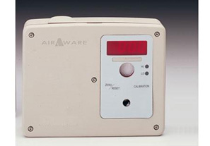

Fixed Transmitters -AirAware™

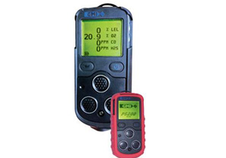

Portable Gas Detector - PS200 MultiGas Detector

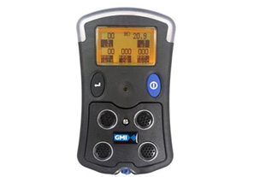

PS500 Gas Detector

